Lab Assignment-1
School of Engineering and Technology
Course Name & Code: Operating System Lab ENCA252
Program Name: BCA (AI & DS) (Research)

Title: CPU Scheduling.
Objective: To implement and compare FCFS and SJF algorithms.

Logic Used:Briefly mention that FCFS follows the order of arrival, while SJF selects processes based on burst time.

Example Data
Process ID | Arrival Time (AT) | Burst Time (BT)
P1 | 0 | 7
P2 | 2 | 4
P3 | 4 | 1
P4 | 5 | 4

OUTPUT:
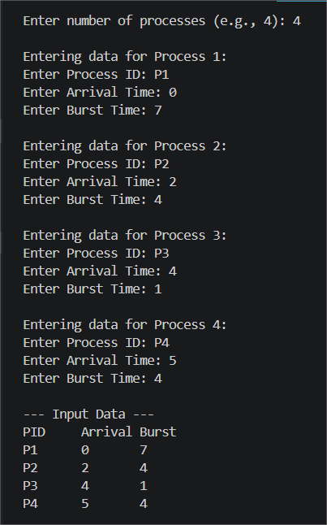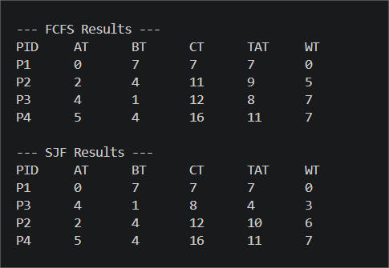

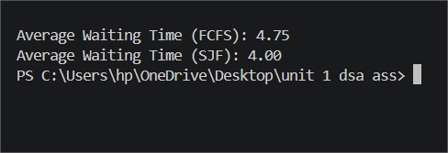

Why this example is good?
- In FCFS: P1 will finish first (at time 7), then P2, then P3, and P4. P3 has to wait a long time even though it only needs 1 unit of time.
- In SJF: After P1 finishes at time 7, the CPU will look at P2, P3, and P4. Since P3 has the smallest Burst Time (1), it will go first! This perfectly shows how SJF is more efficient.

Conclusion: "SJF is better because it reduces Average Waiting Time."

